***Testing Report***

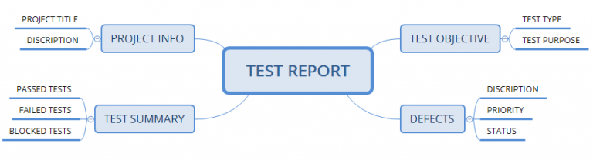

|  |  |
| --- | --- |
| Test Report | Role call App |
| Prepared by: Fondze Alphonse | * Fondze Alphonse * Vernyuy Basile Njodzeven * Nchuyeke Sadian |

1. ***Project information:***
2. **Project Title**
3. **Description**
4. ***Test Summary:***
5. **Passed Tests**
6. **Failed Tests**
7. **Blocked Tests**
8. ***Test Objective:***
9. **Test Type**
10. **Test Purpose**
11. ***Defects:***
12. **Description**
13. **Priority**
14. **Status**